**Individual assignment-MSc(CS) programme app**

1. **This is an individual assignment. All of works are done by myself.**
2. **My android studio version:**

Android Studio 3.2

Build #AI-181.5540.7.32.5014246, built on September 18, 2018

JRE: 1.8.0_152-release-1136-b06 amd64

JVM: OpenJDK 64-Bit Server VM by JetBrains s.r.o

Windows 10 10.0

1. **minSdkVersion:**

minSdkVersion 18 android 4.3 (Jelly Bean)

targetSdkVersion 28

By targeting API 18 and later, this app will run on approximately **95.9%** of devices.

1. **Major function**
2. **Main Window:**

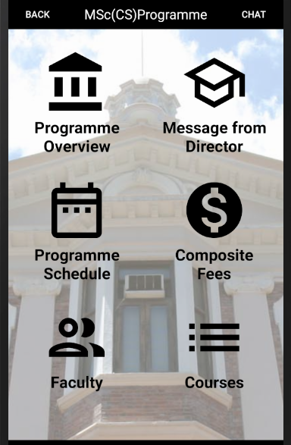

**Function:** Main window consists of one self-defined tile and 6 main functions.

**Related file:**

MainActivity: java file to control this activity.

MainItem: a class consists of one icon and corresponding text.

MainItemAdapter: the adapter between the main layout RecyclerView and its item layout.

TitleLayout: Self-defined title layout with two buttons BACK and CHAT and one text.

Icon selection: https://material.io/tools/icons/?icon=alarm_off&style=baseline

1. **Programme Overview**

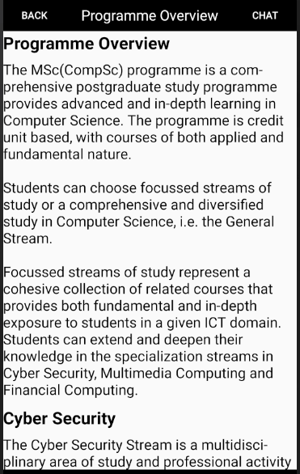

**Function:** Introduction to the programme

**Related file:**

OverviewActivity: java file to control this activity.

OverviewItem: a class consists of one title and corresponding contentID (main content is included in the R/strings file).

OverviewActivityAdapter: the adapter between the main layout RecyclerView and its item layout.

1. **Message from Director**

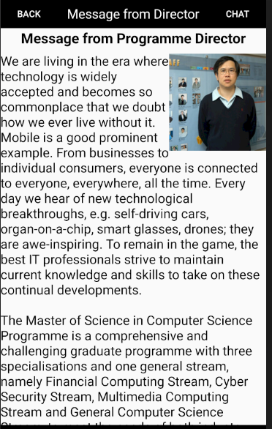

**Function:** message from our programme director

**Related file:**

MsgDirectorActivity: java file to control this activity.

MixtureTextView : layout allows the image is surrounded by the text.

https://github.com/hongyangAndroid/MixtureTextView

1. **Program schedule**

**Function:** introduce the duration of study and class schedule.

**Related file:**

ScheduleActivity: java file to control this activity.

1. **Composite Fees**

**Function:** introduce the composition fees and financial assistance.

**Related file:**

FeeActivity: java file to control this activity.

1. **Faculty**



**Function:** introduce our faculty with professor’s image, name, status, email and field of research.

**Related file:**

TeacherListActivity2: java file to control this activity.

Teacher2: a class corresponds to each professor’s information (image, name, status, email and field of research).

TeacherAdapter2: the adapter between the main layout ListView and its item layout.

teacher2.txt: R/raw, information about the professor

Each file has corresponding file without “2”. That layout doesn’t contain the professor image and email.

1. **Courses**

**Function:** introduce different stream courses

**Related file:**

CoursesActivity: java file to control this activity.

Course: a class consists of course index and title.

CourseAdapter: the adapter between the main layout ListView and its item layout.

1. **Chat function**

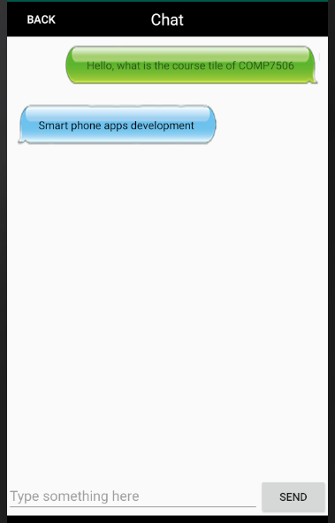

**Function:** when user uses this app and come up with some questions about our program, user can use this chat function to directly communicate with our officers of MSc (CS) programme.

**Related file:**

ChatActivity: java file to control this activity.

Msg: a class consists of left side message chatbox and right side message chatbox.

MsgAdapter: the adapter between the main layout RecyclerView and its item layout.

1. **Other activity**

BaseActivity: convient to know the activity name when you open one activity in the Logcat window.

1. **Execution process**

Install android studio, SDK and JDK->

Open an existing Android Studio project->

choose MSc(CS) programme file->

run 'app'->

choose proper virtual devices (API version >=18)->

OK